**Finance**

**Assignment questions**

**Spring 2018**

*Dear Students,*

*Please find bellow the questions for the first assignment. This is an individual assignment and although I encourage you to discuss it with classmates, you are expected to submit your works individually before the deadline. Please try to follow the guidelines (e.g. word count) where appropriate and as much as possible. You are expected to submit all of your answers in one file prior to the stated deadline (in word or pdf).*

**Q1.** Chose one financial intermediary from each type of non-banking institutions (long-term saving institutions, risk spreaders and risk takers) and **explain how they channel household savings into financial investment (200 words max)**

A financial intermediary is a financial institution such as bank, building society, insurance company, investment bank or pension fund. They permit indirect lending. In indirect lending, savers in the economy lend their funds to intermediaries, and the intermediaries lend these funds to borrowers.

* Long-term saving institutions

Let’s take the example of **pension funds** and see their importance in financial investments. Pension funds are set up to provide pension for members. E.g. when a member retires the USS will pay a pension. The long time horizon of it means that large sums are built up for investment - several billions.

* Risk spreaders

These institutions allow small savers a stake in a large diversified portfolio. Thus investors can contribute a small amount each month to an investment fund alongside thousands of other investors and then the pooled fund is professionally managed.

**Open-ended investment** **companies** are hybrid risk-spreading instruments which allow an investment in an open-ended fund. They have just one price and therefore are more flexible.

* Risk takers

They transform household savings with low risk to financial investments with higher risk by putting together all the small amounts of savings in a bigger investment with bigger risk. They could be **hedge** **funds** that gather together investors’ money and invest it in a wide variety of finance strategies largely outside the control of the regulators. Risk is eliminated by seeking absolute return.

**Q2.** Gordons plc has an annual turnover of £3 million and a pre-tax profit of £400,000. It is not quoted on a stock exchange and the family owning all the shares has no intention of permitting the sale of shares to outsiders or providing more finance themselves. Like many small and medium-sized firms, Gordons has used retained earnings and a rolled-over overdraft facility to finance expansion. This is no longer seen as adequate, especially now that the bank manager is pushing the firm to move to a term loan as its main source of external finance.

You, as the recently hired finance director, have been in contact with some financial institutions. The Matey hire purchase company is willing to supply the £1 million of additional equipment the firm needs. Gordons will have to pay for this over 25 months at a rate of £50,000 per month with no initial deposit.

The Helpful Leasing Company is willing to buy the equipment and rent it to Gordons on a finance lease stretching over the four-year useful life of the equipment, with a nominal rent thereafter. The cost of this finance is virtually identical to that for the term loan, that is, 13 per cent annual percentage rate.

**Required. Write a report for the board of directors explaining the nature of the four forms of finance which may be used to purchase the new equipment: hire purchase, leasing, bank term loan and overdraft. Point out their relative advantages and disadvantages. (350 words max – you might want to simple create a table and explain pros and cons)**

D

**Q3. Describe, explain and illustrate how a bank could find itself insolvent. (200 words max +** **tables if required)**

Being insolvent means being unable to pay debts owed because its liabilities > assets. Banks “create” money, how could they possibly become insolvent? Can’t they create money to cover their losses?

* Customers defaulting on their loans

Normally, the shareholder equity is positive and the bank is solvent, with assets > liabilities. 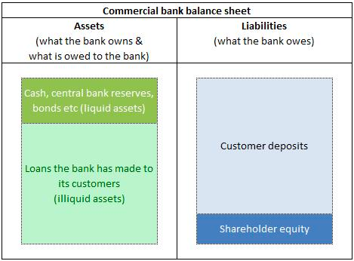

Some customers default on loans. Banks can absorb loan defaults at first. 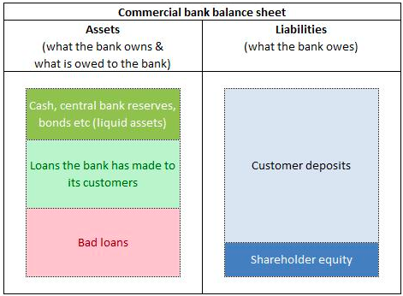

If bad loans are certain not to be repaid, they are removed from the balance sheet; resulting in liabilities > assets and insolvency.

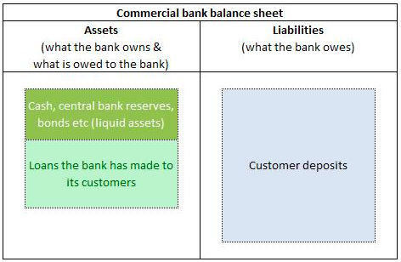

* Bank run: not enough liquid short-term assets to meet short-term liabilities

Healthy position, even if some borrowers default, there is a buffer of shareholder equity to protect from any losses.

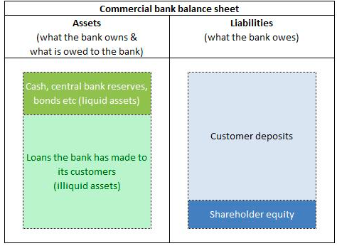

For whatever reason people withdraw their money. The amount of cash held by the banks can quickly run out due to this as well as the amount of reserves at the central bank. 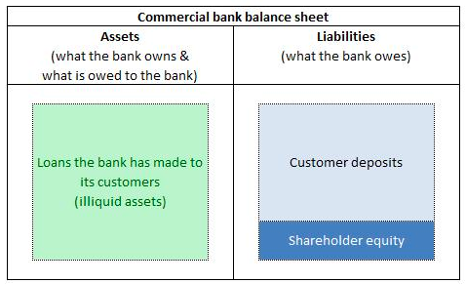

Bank can try getting cash by selling bonds, shares, to raise additional cash, but once these liquid assets are depleted, the bank cannot make payments.

Banks need to recover and need cash, they need it at present. Selling illiquid assets will take too much time so they have to sell at inferior prices. It may become insolvent, the bank has no other way to repay its depositors as liabilities > assets.

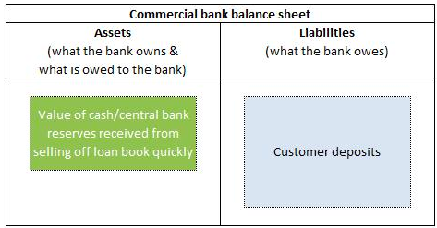

**Q4. Describe and explain how investment banks assist companies wishing to raise finance/capital. (200 words max)**

Investment banks facilitate flows of funds and allocations of capital. They are financial intermediaries between companies that want to issue new securities – and want to raise capital at the lowest possible overall (all-in) cost – and the buying public. They provide financial advice to businesses and help them raise capital through the sale of stocks, bonds, and other products.

Issuers want to raise capital at the lowest possible overall (all-in) cost; therefore investment banks can advise on the advantages and disadvantages of each path and suggest the one to take. They often have the knowledge, contacts, and reputation to be able to bring a company needing finance to potential investors. They can help price a new issue of bonds or shares, having awareness of market condition. They can assist in selling securities, they know the legal and regulatory hurdles that have to be stepped over or manoeuvred around. They will also underwrite new security issues – guaranteeing to buy any not purchased by other investors. Furthermore, in order to raise finance, they help with initial public offerings (IPOs), when a company issues shares on the market for the first time and assist with seasoned equity offerings (SEOs), the issue of new shares for a company already listed.

All in all, they have various ways in which they can help companies or governments raise finance.

**Q5. Explain the following key elements to insurance: (200 words max) (a) asymmetric information; (b) adverse selection; (c) moral hazard; (d) float.**

* Asymmetric information

Asymmetric information, also known as information failure, occurs when one party to an economic transaction possesses greater material knowledge than the other party. This normally manifests when the seller of a good or service has greater knowledge than the buyer, although the reverse is possible. Almost all economic transactions involve information asymmetries.

* Adverse selection

It refers to the tendency of high-risk individuals obtaining insurance or when one negotiating party has valuable information another lacks. It occurs when there is an opportunity or incentive for some firms to act to take advantage of their informational edge over others. Then, the firms doing that activity will be disproportionately those taking advantage rather than being truly representative of the population as a whole. This will raise the cost of insurance for the whole group, including those less-than-average risk. There is a tendency for people in dangerous jobs or with high-risk lifestyles to buy insurance, knowing that insurance premiums are based on averages and that they will be at an advantage.

* Moral hazard

It recognizes the danger that a party protected in some way from risk will act differently than if they didn’t have that protection and be less careful. For example, an insured person may not lock the car; “it’s insured anyways”.

* Float

It is money in the banking system that is briefly counted twice due to delays in processing checks. Float is created when a bank credits a customer’s account as soon as a check is deposited. However, it takes some time for the check to be received from the payer’s bank. Until the check clears from the payer’s bank, the amount of the check appears in the accounts of both the recipient’s and payer’s banks.

**Q6. Distinguish between funded and unfunded pension schemes, and give the advantages and drawbacks of each type of pension. (150 words max)**

**Unfunded pension schemes** are pay as you go (PAYG) schemes where the money put aside each month by employees and employers pays the pensions of current pensioners. This means that there is no pot of accumulated money to pay pensions. If there is a shortfall, it is met by the Treasury which is an advantage. A drawback would be that many countries are in the process of reforming their pension provisions as these schemes have begun to prove unsustainable with the increasing age of the population and its growing dependency on the state.

**Funded pension schemes** are designed so that the insured, and their employers, make regular payments to a pension fund, which will (hopefully) grow and provide future pension income. The advantage is that it has enough assets to pay its obligations to retirees for the foreseeable future, but they depend on continuous new contributions to continue paying the retirement benefits for all eligible employees and there is a lack of options when it comes to flexibility in investment.

|  |  |  |
| --- | --- | --- |
|  | Advantages | Drawbacks |
| Funded pension scheme | Enough assets for foreseeable future | Lack of options, depend on new contributions |
| Unfunded pension scheme | Guaranteed income | Unsustainable |

**Q7.** On 1 March 2011 a company raises finance by agreeing a six-month eurodollar loan for $20 million offered at an interest rate of 2.15 per cent. **Calculate the cost of the loan in dollars.**

1. **on a 30/360-day count basis (180 days)**

Cost of loan –> Interest payment = (20,000,000 x 0,0215) x 180/360 = **215 000$**

**(b) on a 365-day count, actual/365 basis (183 days)**

Cost of loan –> Interest payment = (20,000,000 x 0,0215 x 183/365) = **215 000$**

**Q8.** You purchase $10,000 worth of six-month US Treasury bills on the secondary market with a quoted yield per annum of 0.64 per cent. The bills have 36 days to maturity. **How much would you pay? Use the actual/360-day count convention.**

Interest payment = 10,000 x 0,0064 x 36/360 = 6,4$

**Q9.** The annualised yield on a repo with an initial sale value of £800,000 is 1.85 per cent. The repo has 61 days until maturity.

1. **What will be the repurchase price? 360-day convention**

Interest = 800 000 x 0,0185 x 61/360 = 2 507,8£

1. **If the days to maturity are 92, what will be its future purchase price? Use a 360-day count convention throughout.**

Interest = 800 000 x 0,0185 x 92/360 = 3 782,2£

**Q10.** As a winner of a lottery you can choose one of the following prizes: 1) £1 million now. 2) £1.5 million at the end of five years. 3) £80,000 a year forever, starting in one year. 4) £150,000 for each of the next ten years, starting in one year. **If the time value of money is 8 per cent, which is the most valuable prize?**

* 1 million now

**Present Value = 1,000,000**

* 1.5 million at the end of 5 years

**PV** = 1.500.000 /(1,08)^5 = **1.020.874,8**

* 80,000 a year, forever, starting in 1 year

**Present value of perpetuity PVP** = A / r = 80,000 / 0,08 = **1.000.000**

* 150 000 for each of the next 10 years, starting in 1 year

*(1 - 1/(1,08)^10) / 0,08 * 150.000 = 3.897.984*

* The most valuable one is

**Q11. What is the present value of £1000 to be received in ten years’ time when the interest rate (nominal annual) is 9 per cent and**

1. **annual discounting is used?**

Return after one year 1000(1+0,9) = 1 900£

Present value = future value / (1+i)^n

1. **semi-annual discounting is used?**

Return after one year 1000(1 + (0,9/2))(1 + (0,9/2)) = 2 102,5£

__

Maturity value = principle + interest = 1090

**Q12.** Punter buys a car on hire purchase paying five annual instalments of £2,500, the first being an immediate cash deposit. **Assuming an interest rate of 8 per cent is being charged by the hire-purchase company, how much is the current cash price of the car?**

5 annual instalments of 2 500; interest rate of 8%

current cash price?

**Q13.** Imagine that the market yield to maturity for three-year bonds in a particular risk class is 11 per cent. You buy a bond in that risk class which offers an annual coupon of 9 per cent for the next three years, with the first payment in one year. **The bond will be redeemed at par (£100) in three years. How much would you pay for the bond?**

Purchase price = face value x ( 1 – (discount x days to maturity/days in year))

= 100 x (1 – (0,11 x 99)/365)) = 99,97

**Q14.** A bond will pay an annual 7.5 per cent coupon until maturity (the next coupon will be paid in one year). The bond matures in six years.

1. **What will be the market price of the bond if yields to maturity for this risk class fall to 6.5 per cent?**

*6,5 = (100-purchase price)/100 x 365/*

1. **What will be the market price of the bond if yields to maturity for this risk class rise to 8.5 per cent?**

D